Good Morning,  
As noted in my email, I have been attempting to solve the problem in handout three. I have employed two different techniques for solving the relaxed problem given a set of relaxation coefficients u, a mixed-integer solver called ORTOOLs and the approach advised in the handout for uncapacitated fixed charge relaxed problems, wherein x is solved using the function v and y is then solved. For a given set of u’s, both approaches produce the same selected facilities for me. However, I am quite confident from looking at the map of solutions on the following pages that these selected facilities are incorrect, leading me to suspect that my calculation of each generation of u or t is incorrect. I have inserted below a screenshot of my code for updating u and step size, and was wondering if you might help me find my error in logic. I am sorry for requesting this assistance via email, I am out of town this week. Thank you!

Very Respectfully,

Noah

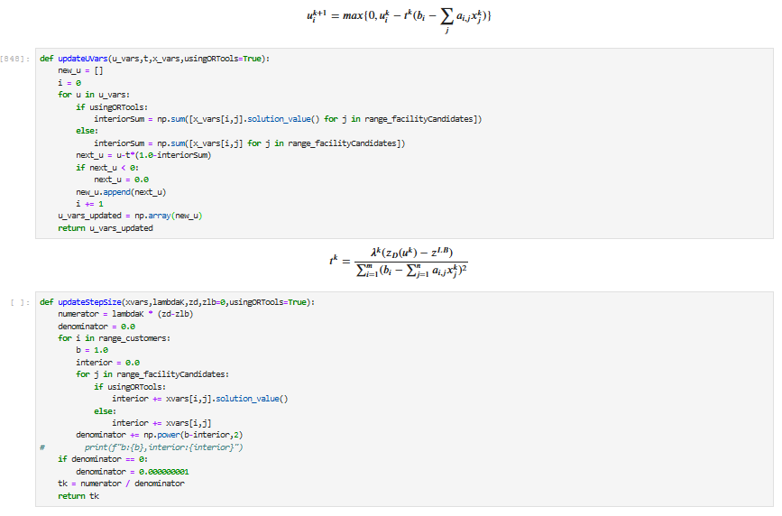

Figure . Code for updating U and T

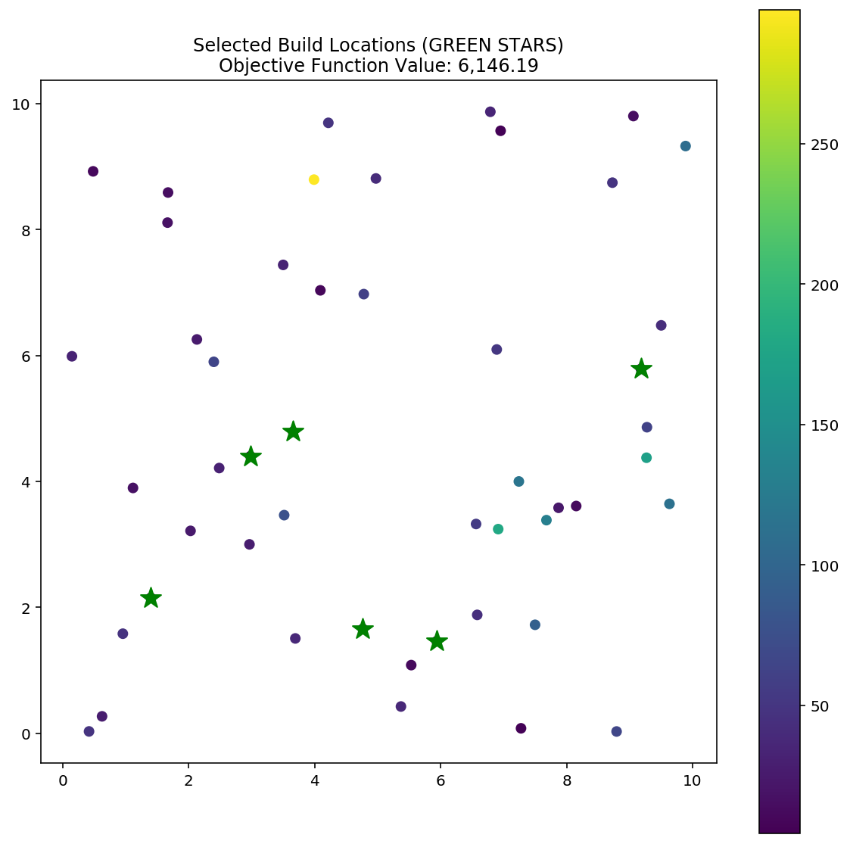

Figure . Solution achieved using numerical solver on relaxed equation

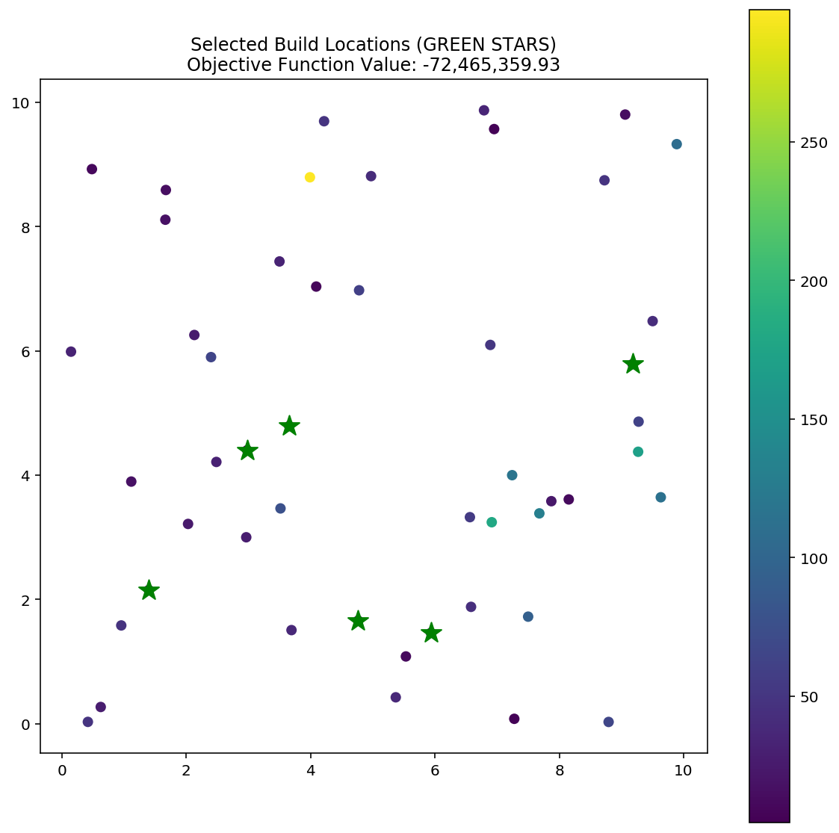

Figure . Solution achieved using solution technique from course handout